Baye’s Theorem in Real Life

Introduction
Introduction to Probability in Real Life
- In everyday life, we often make decisions under uncertainty.
- Doctors diagnose diseases.
- Email systems detect spam.
- Courts evaluate evidence.
- These decisions involve probabilities.
- Bayes’ Theorem helps us update probability when new evidence is available.
What is Bayes’ Theorem?
Bayes’ Theorem is a mathematical formula used to find the probability of an event based on prior knowledge of related conditions.
Formula:
P(A|B) = (P(B|A)* P(B))/( P(B))
Where:
- P(A|B) = Probability of A given B (Posterior probability)
- P(B|A) = Probability of B given A (Likelihood)
- P(A) = Prior probability
- P(B) = Total probability of B

Chosen Real-Life Scenario: Medical Testing
We will consider a disease testing scenario.
Suppose:
- A disease affects 1% of the population.
- The medical test:
  - Is 99% accurate for infected people.
  - Has 5% false positive rate.
We want to find:
If a person tests positive, what is the probability they actually have the disease?
Step-by-Step Mathematical Calculation
1. Given Data
- P(Disease) = 0.01
- P(No Disease) = 0.99
- P(Positive | Disease) = 0.99
- P(Positive | No Disease) = 0.05
Step 1: Calculate Total Probability of Testing Positive
P(Positive) = (P(Positive | Disease)*P(Disease))+(P(Positive | No Disease)*P(No Disease))
Substitute values:
- P(Positive) = (0.99*0.01) + (0.05*0.99)
- P(Positive) = 0.0099 + 0.0495
- P(Positive) = 0.0594
Step 2: Apply Bayes’ Theorem
- P(Positive | Disease) = (0.99*0.01) / (0.0594)
- P(Positive | Disease) = 0.0099 / 0.0594
- P(Positive | Disease) = 0.1666
Final Answer
Probability that a person actually has the disease after testing positive = 16.66%

Visual Explanation of Probability Flow
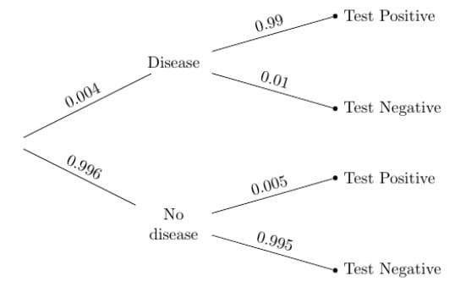
- Most positives come from healthy people.
- This is because disease prevalence is very low.
- Even accurate tests can mislead when disease is rare.

Interpretation & Real-Life Meaning
Important Observation
Even though:
- Test accuracy = 99%
- False positive rate = 5%
The actual chance of having disease after positive result is only 16.66%

Why Does This Happen?
- Disease is rare (1%)
- Large number of healthy people
- Small false positive rate applied to large healthy population creates many false alarms

Real-Life Implications in Healthcare
- Doctors do confirmatory tests
- Avoid panic from first test
- Consider:
  - Medical history
  - Symptoms
  - Risk factors

Decision-Making Using Bayes’ Theorem
Doctors mentally apply Bayesian thinking:
- Prior belief (disease rate)
- New evidence (test result)
- Updated probability (posterior)
Prior vs Posterior Concept
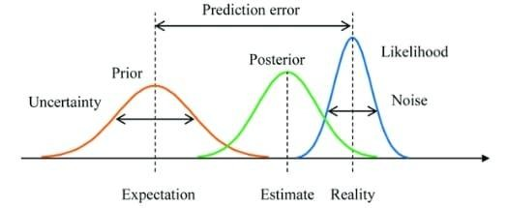
- Prior probability = before evidence
- Posterior probability = after evidence
- Evidence shifts belief

Extension to Other Real-World Applications
- Email Spam Filtering Companies like:
  - Google (Gmail)
  - Microsoft (Outlook)
  - Use Bayesian filtering.
Words like "FREE", "WIN", "OFFER" increase spam probability.
System updates probability as more words are analyzed.
- Criminal Investigation
  - Prior: Suspect likelihood
  - Evidence: DNA match
  - Posterior: Updated guilt probability
- Machine Learning
Bayesian inference is used in:
  - Predictive models
  - AI systems
  - Risk analysis

Advantages of Bayes’ Theorem
- Handles uncertainty
- Updates beliefs logically
- Useful in small data scenarios
- Helps reduce decision errors

Conclusion
- Bayes’ Theorem is not just a formula.
- It is a decision-making framework.
- In medical testing:
▪ A positive result does NOT guarantee disease.
It teaches us:
- Always consider prior probability.
- Do not rely only on test accuracy.
- Understand context before making conclusions.

